# **Banking Application**

**Modules:**

1. Check Balance
2. Deposit
3. Withdraw
4. Transfer
5. Exit

**Software Specifications:**

Client side technologies: HTML, CSS, Javascript

Programming Language: Java

Server side technologies: J2EE (Servlets and JSP)

Web Server: Tomcat

Database: Oracle

**Hardware Specifications**

Operating System: Windows family, Linux family

RAM: Min 500 MB

Processor: any processor

**Database tables:**

Note: We are not using separate login table temporarily.

**LOGIN**

create table login (userId varchar2(50) PRIMARY KEY, password varchar2(50));

insert into login values('101010','nxt123');

insert into login values('101011','nxt124');

commit;

select * from login;

**ACCOUNT**

CREATE TABLE account

(

account_number NUMBER primary Key,

FIRST_NAME VARCHAR2(50),

LAST_NAME VARCHAR2(50),

BALANCE NUMBER(10,2),

userid VARCHAR2(50) ,

FOREIGN KEY(userid)

REFERENCES login (userid)

);

**INSERT QUERY**

INSERT INTO ACCOUNT VALUES (111222,'Rajesh','AR', 50000, 101010);

INSERT INTO ACCOUNT VALUES (111223,'Tarangini','D', 50000, 101011);

COMMIT;

**Directory Structure of the application:**

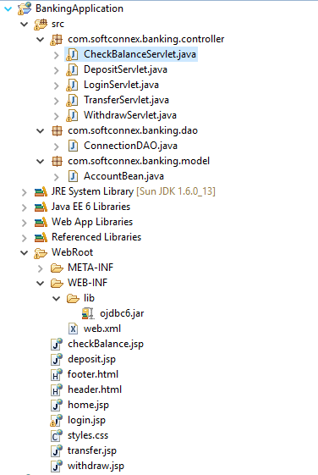

**Resource Files:**

header.html

footer.html

login.jsp -It’s for login purpose

home.jsp

checkBalance.jsp

deposit.jsp

withdraw.jsp

transfer.jsp

**Controllers:**

LoginServlet.java

CheckBalanceServlet.java

DepositServlet.java

WithdrawServet.java

TransferServlet.java

**DAO:**

ConnectionDAO.java

**Model:**

AccountBean.java

**Screens:**

**Login Screen:**

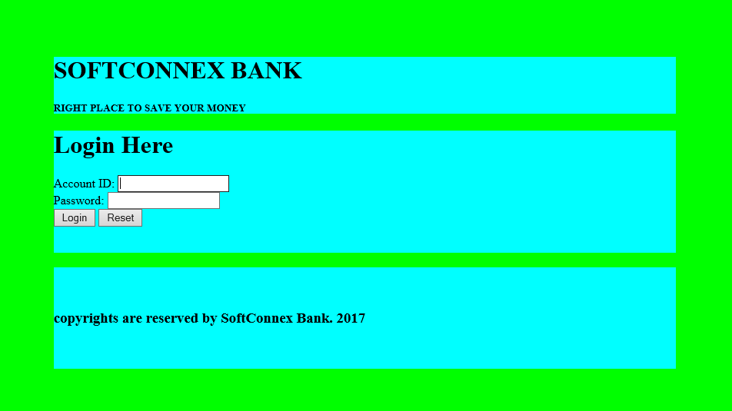

**Login Failure:**

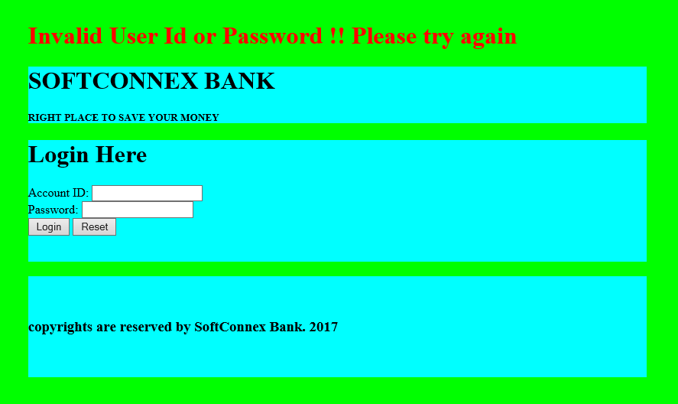

**Home Screen (Login success)**

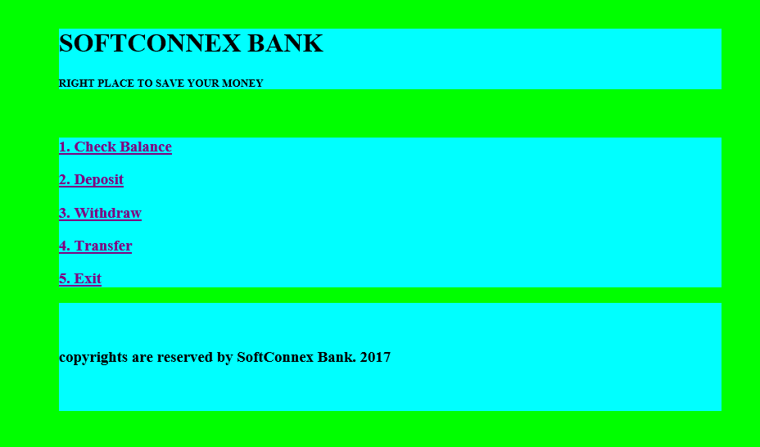

**Check Balance screen:**

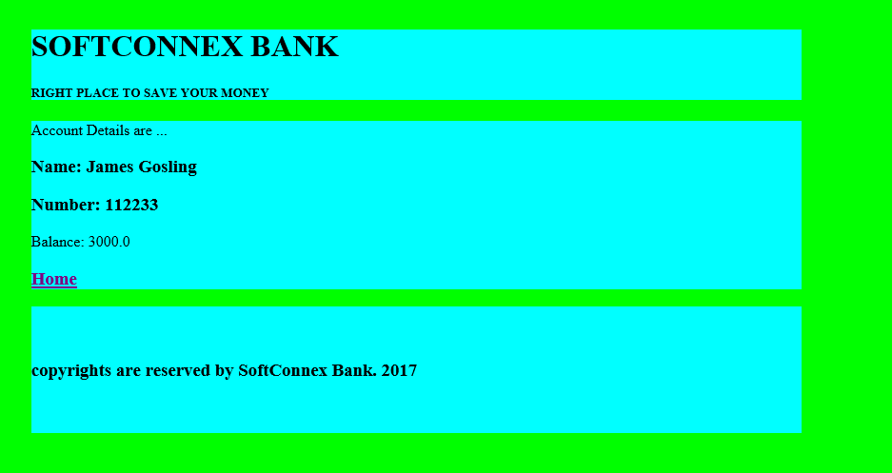

**Deposit screen:**

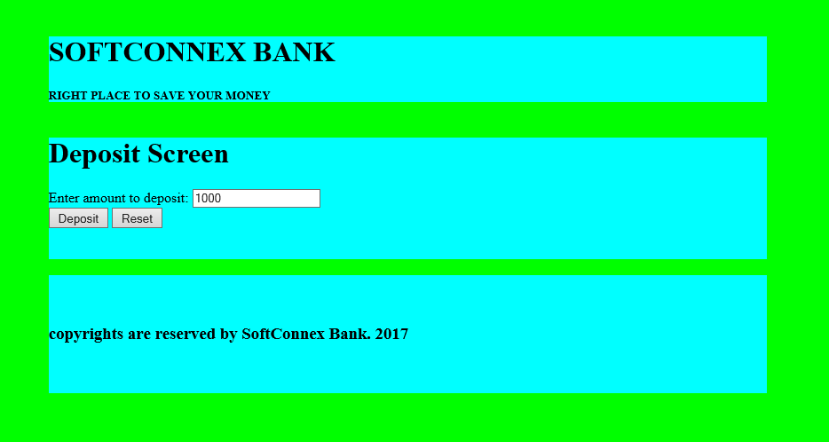

**Home screen (Deposit is done)**

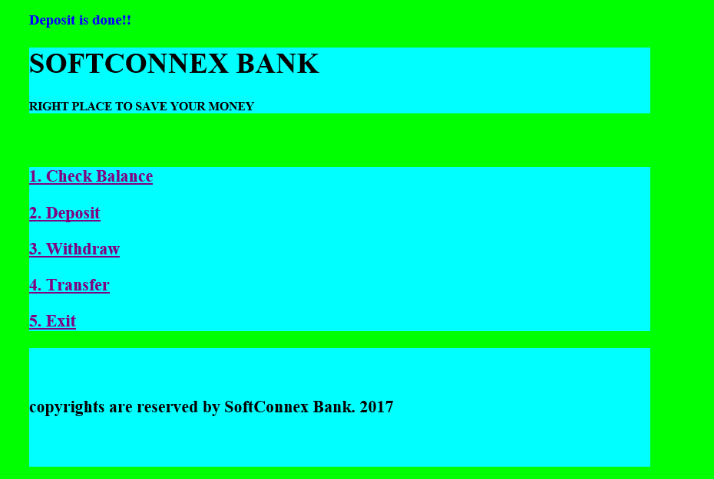

**Withdraw screen:**



**Home screen (Withdrawn is done)**



**Transfer screen:**

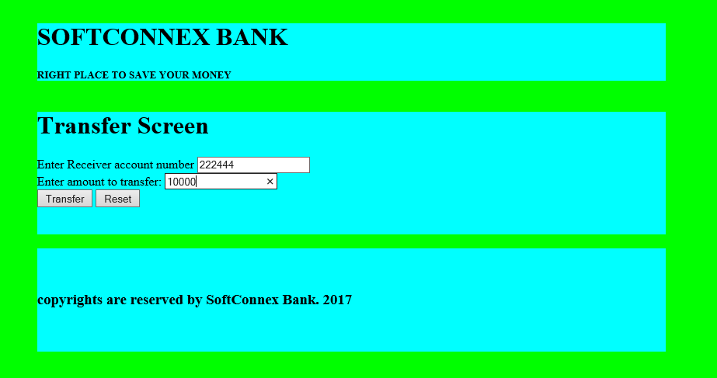**Home Screen (Transfer is done)**

